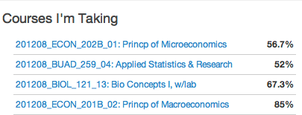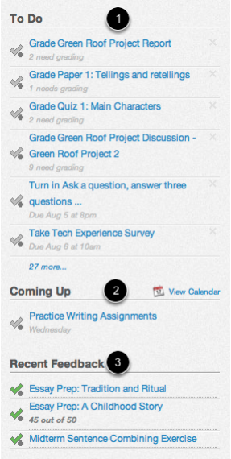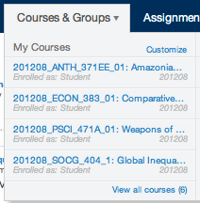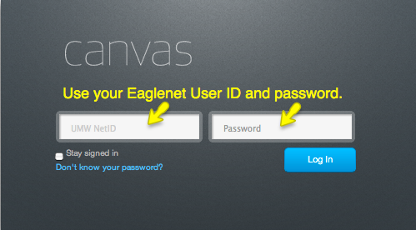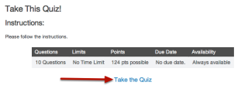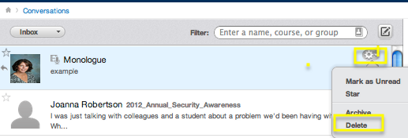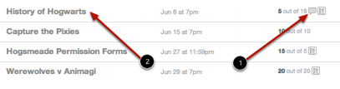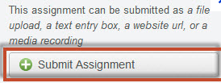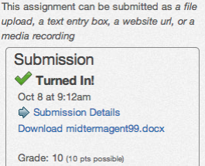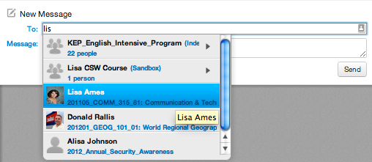

Click on **Grades.** You will see your course averages. Click on a course to view grade details.

## How do I view my grades?

Click on **Settings** then click directly on the *Placeholder* *Profile* *picture*.

Now **Upload a new Image** > **Choose File** > **Add File** > **Select Image**

The **Sidebar** gives you three help summaries: *To Do*, *Coming Up*, and any *Recent Feedback*.

## How do I know when I have something due?

Canvas Overview

Click on your **User Name** > **Edit Profile** to change your preferred name; designate ways to contact you (Facebook, Twitter, Google, Skype, Canvas Conversations); add blog links; and create a detailed bio > then click **Save Profile** to update.

You see this screen when you log in to Canvas and by default inside each course. It displays the activity of your courses by showing events, announcements, discussions, grade postings and more.

## What is the Recent Activity screen?

Click on **Help** in the corner or your Canvas screen to:

* Report a problem
* Ask your instructor a question
* Contact the UMW Helpdesk

Look under **Courses & Groups**. * Your course will not show if the instructor has not published it!

## Where can I find my course?

## How can I get help?

Click on **Settings** to customize your personal info. Add a second e-mail; your cell # for text messaging; and even your Facebook, Twitter, or Skype name to designate where messages should go and how often you’d like to receive them.

## How do I set up my notification preferences?

## How do I add a Profile picture?

Click on your **User Name** > Profile > Edit Profile to:

* change your preferred name
* designate how to contact you
* add your bio
* add links to your blog

## How do I edit my Profile?

Log in @ <https://canvas.umw.edu/login>

with your Eaglenet User ID and password.

Getting Started

Managing Your Canvas Account

## How do I log in to Canvas?

Sed justo.

Canvas: Quick Start Guide for Students

Click on **Assignments** > find a particular assignment > click on the speech bubble to view comments.

## How do I look at comments from my instructor?

There’s a Canvas Student Guide and a Canvas Community that can help. Check it out!

Follow the link under **Help**!

## Where can I get answers when the helpdesk is closed?

## ?

## How do I delete conversations and messages?

To delete a conversation go to your **Inbox** > click on the gear wheel in the left pane > then click **Delete**.

To delete individual messages (showing in the right pane) put a check in the box next to the message you want to delete > click on the trash can icon > **Delete.**

Your instructor may have put a quiz under **Quizzes** or **Assignments**. Locate it and click the title > then click Take the Quiz!

From your Assignment, read the instructor’s directions to find out what kind of submission is required. Then click on Submit Assignment!

Look in the sidebar! You will see a green checkmark, date and time stamp verifying your submission.

## How do I know if my assignment got submitted?

## How do I submit an assignment?

Each course has a file repository. If your instructor has enabled it, students can also create folders and upload files to share. **Files** > **Add Files** or **Add Folder**. You can even download or upload a Zip file.

## How do I access my course files?

Go to your **Inbox** > in the *To:* field, start typing your Instructor’s name (it will appear in blue) > enter a message > click**Send**.

Your message will appear at the top of your Conversation list.

* You can also attach a file and record your message!

## How do I send a message to my instructor?

The **Inbox** in Canvas is designed to capture *conversations*. So not only can you create and send a message, but you can view the entire conversation around that message in one place. That’s a time saver!

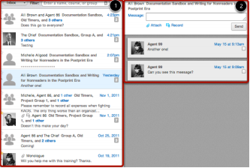

## Why should I use the Inbox?

Communicating in Canvas

Navigating your Canvas Course

## How do I take a quiz?

Navigating your Canvas Course

Sed justo.